1. **Consider the following game tree. Assume that the first player is the maximizing player.**

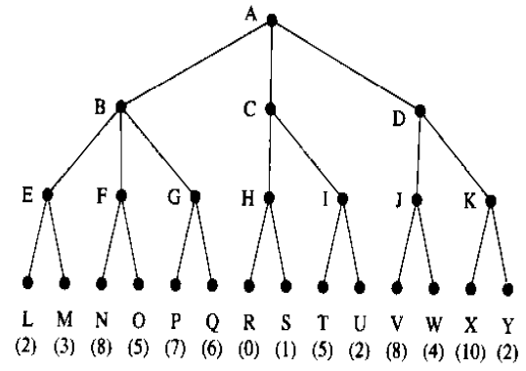

* 1. Which move should the first player choose?
  2. Which nodes are not necessarily examined if using the alpha-beta pruning? Assume that nodes are examined in the left-to-right order.
  3. If the tree is examined in the right-to-left order, are the same node pruned?

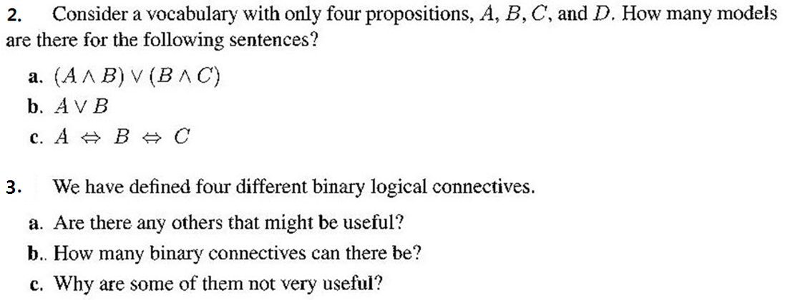

$$as follows: (⋀, ⋁,→, ↔).$$

**4. Prove followings with resolution refutation.**

a. P |= (QP)

b. (P(QR)) |= ((PQ)  (PR))

c. (Q ➢P) |= ((QP)  ➢Q)

**5. Represent the sentences in propositional logic and prove that the unicorn magical.**

If the unicorn is mythical, then it is immortal, but if it is not mythical, then it is a mortal mammal. If the unicorn is either immortal or a mammal, then it is horned. The unicorn is magical if it is horned. The unicorn is not mammal.

6. Consider the following sentences. For each of them, explain if it can be written out in first order logic. If your answer is yes, give the corresponding logical statement. If the answer is no, explain the difficulty.

|  |
| --- |
| human(X): X is a human  fly(X): X can fly  same(X,Y): X and Y are the same (identical or equivalent)  love(X,Y): X likes Y |

* 1. Someone is loved by everyone.
  2. At least two persons can fly.
  3. Most of human can fly.

7. Prove “m(pat)” with resolution refutation.

X[h(X)  Y p(Y,X)]

X[h(X)  (m(X)  f(X))]

XY [p(X,Y)  f(Y)  d(X,Y)]

h(pat)

➢X d(X,pat)